**Q. Develop a web application which involves database operations using NodeJS.**

**CODE: (Create Database)**

var mysql = require('mysql');

var con = mysql.createConnection({

host: "localhost",

user: "root",

password: "",

port: 3308

});

con.connect(function(err){

console.log("Connected!");

con.query("CREATE DATABASE CUST",

function (err, result){

console.log("Database created");

});

});

**OUTPUT:**

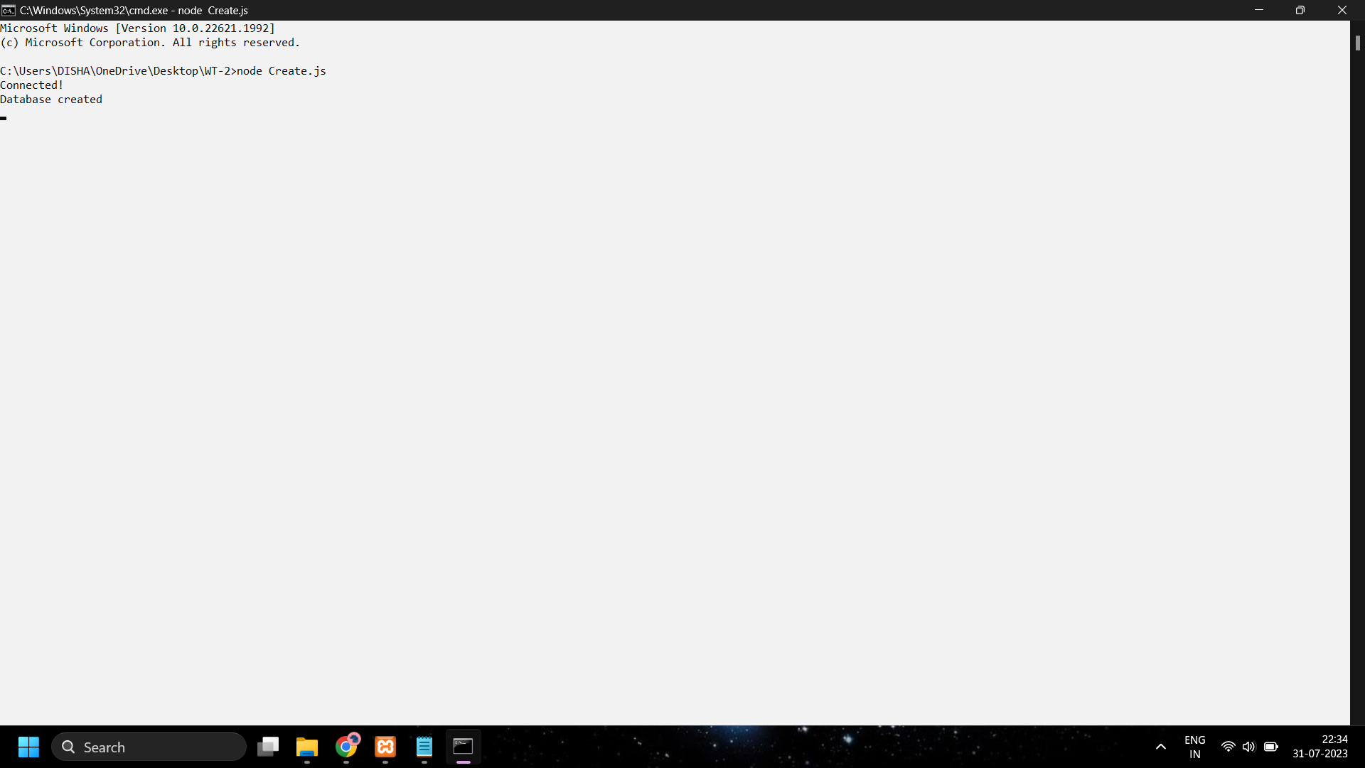

**CODE: (Create Table)**

var mysql = require('mysql');

var con = mysql.createConnection({

host: "localhost",

user: "root",

password: "",

port: 3308,

database: "CUST"

});

con.connect(function(err){

console.log("Connected!");

var sql = "CREATE TABLE customers (name VARCHAR(255), address VARCHAR(255))";

con.query(sql, function(err, result){

console.log("Table created");

});

});

**OUTPUT:**

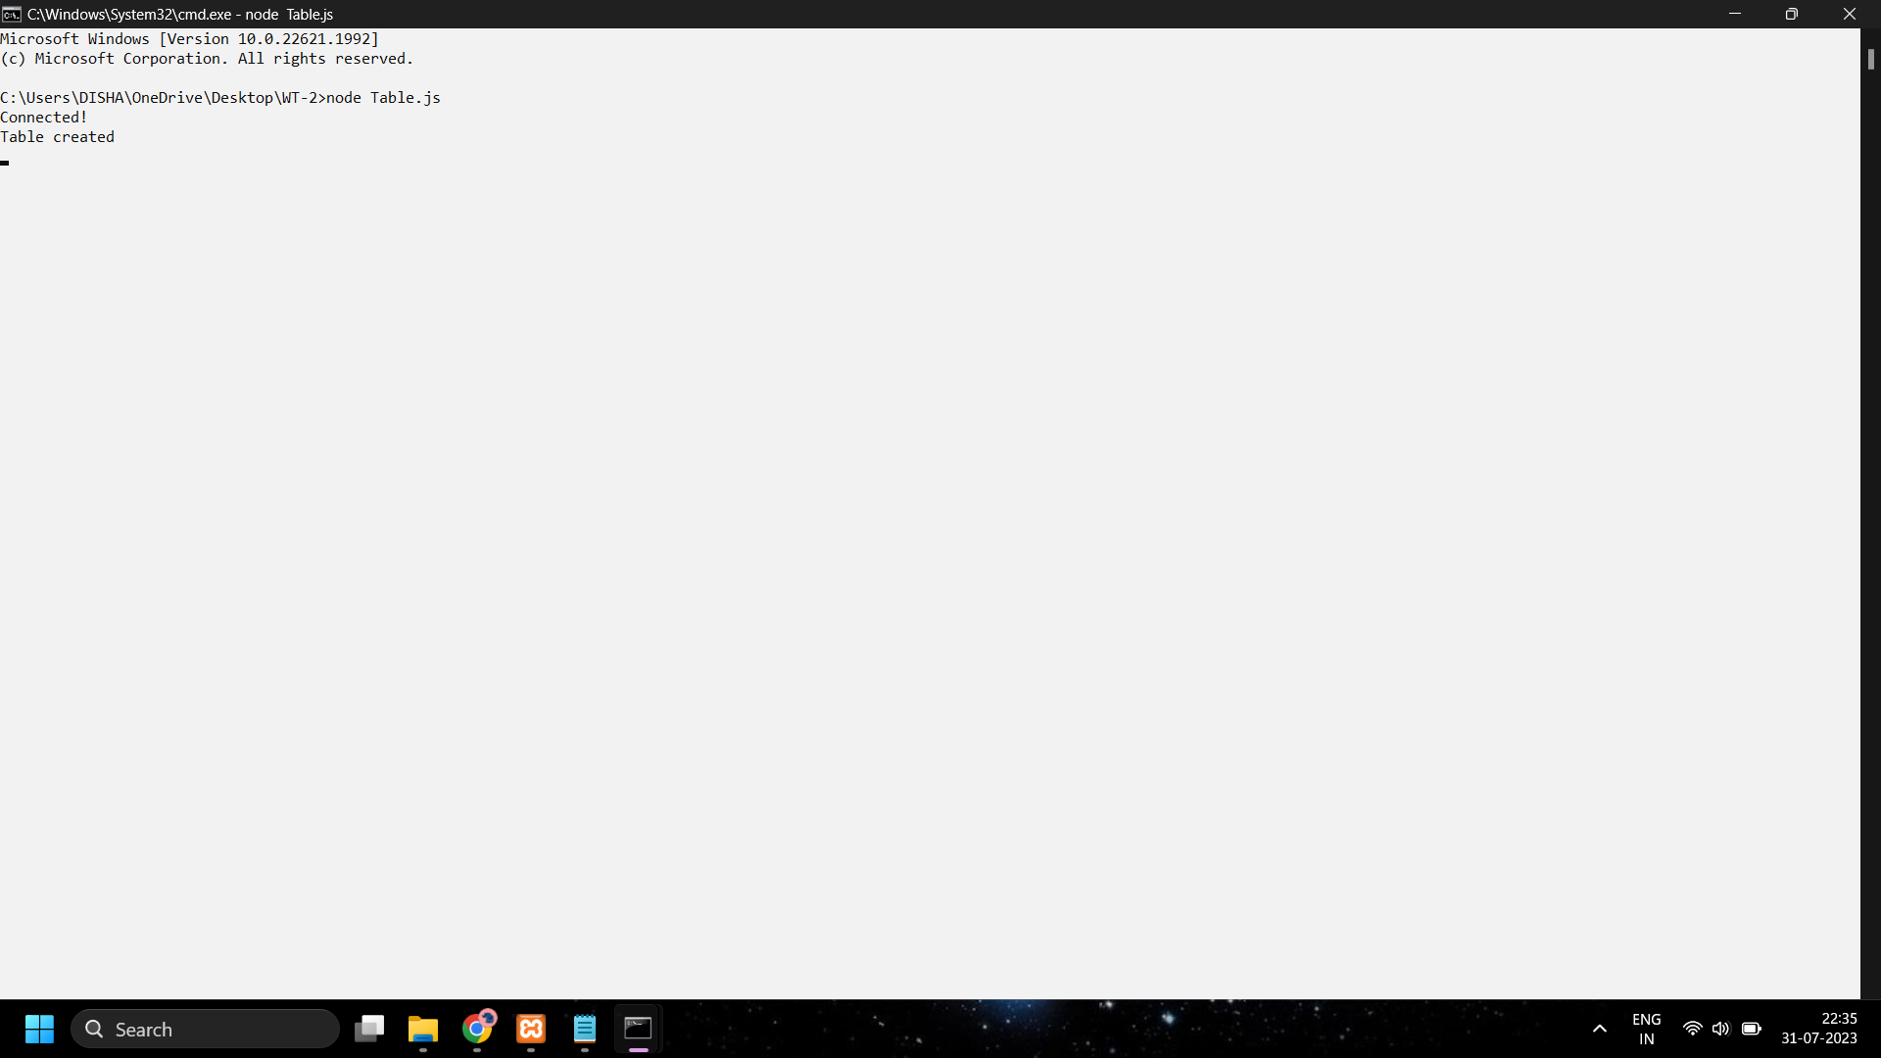

**CODE: (Insert)**

var mysql = require('mysql');

var con = mysql.createConnection({

host: "localhost",

user: "root",

password: "",

port: 3308,

database: "CUST"

});

con.connect(function(err){

if (err) throw err;

console.log("Connected!");

var customer = { name: "Disha", address: "AUB" };

var sql = "INSERT INTO customers SET ?";

con.query(sql, customer, function(err, result){

if (err) throw err;

console.log("1 record inserted");

});

});

**OUTPUT:**

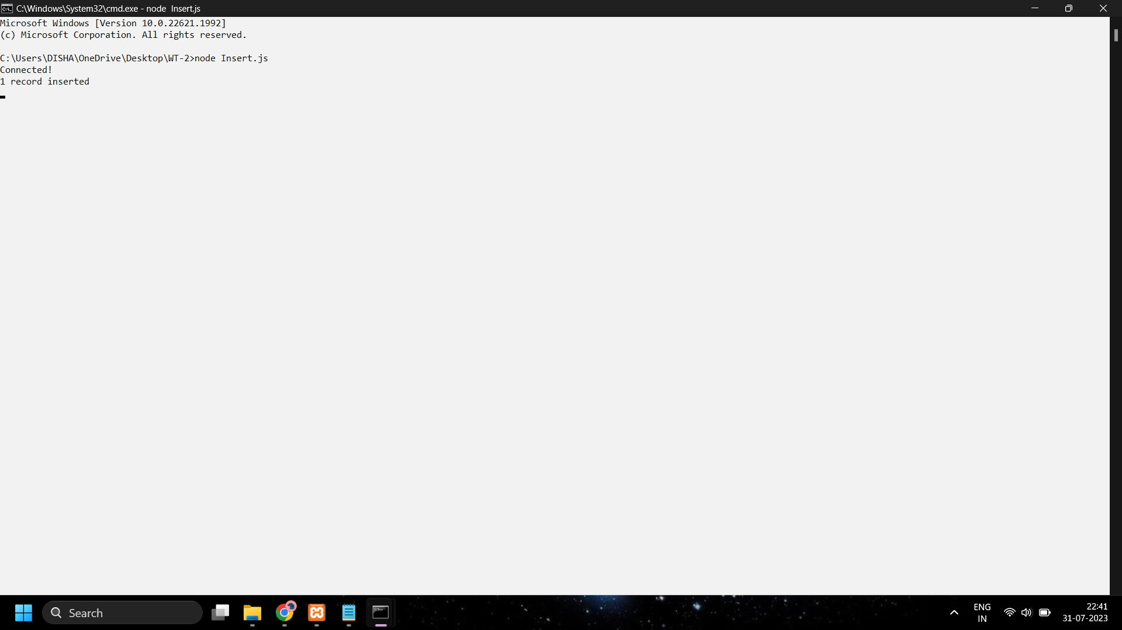

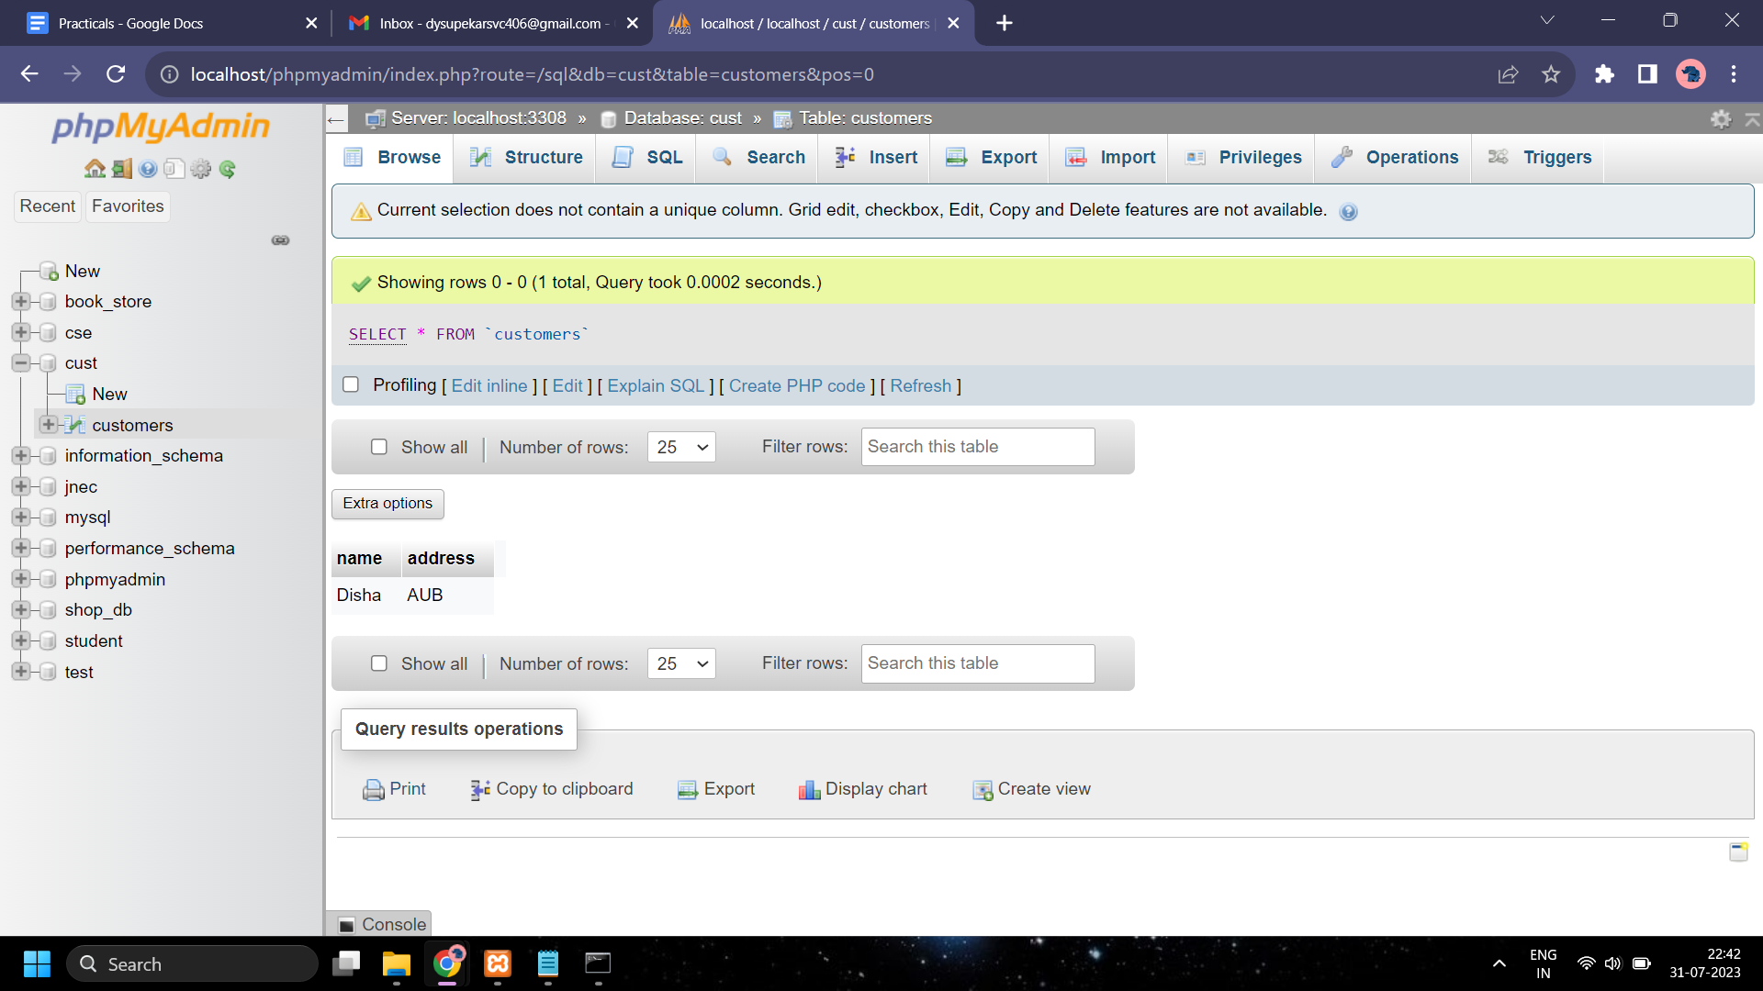

**CODE: (Update)**

var mysql = require('mysql');

var con = mysql.createConnection({

host: "localhost",

user: "root",

password: "",

port: 3308,

database: "CUST"

});

con.connect(function(err){

if (err) throw err;

console.log("Connected!");

var nameToUpdate = "Disha";

var newAddress = "CSN";

var sql = "UPDATE customers SET address = ? WHERE name = ?";

con.query(sql, [newAddress, nameToUpdate], function(err, result){

if (err) throw err;

console.log("1 record updated");

});

});

**OUTPUT:**

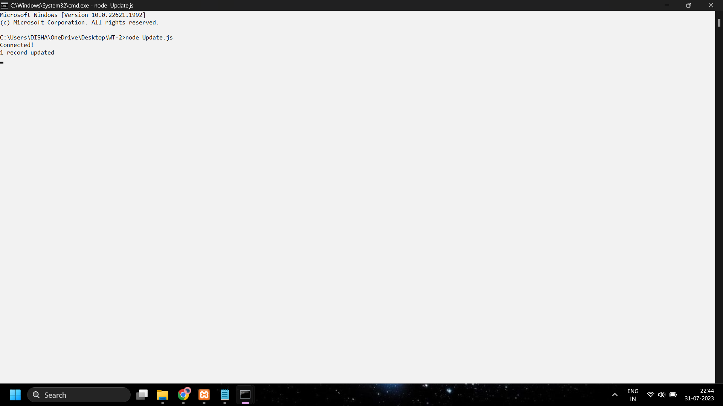

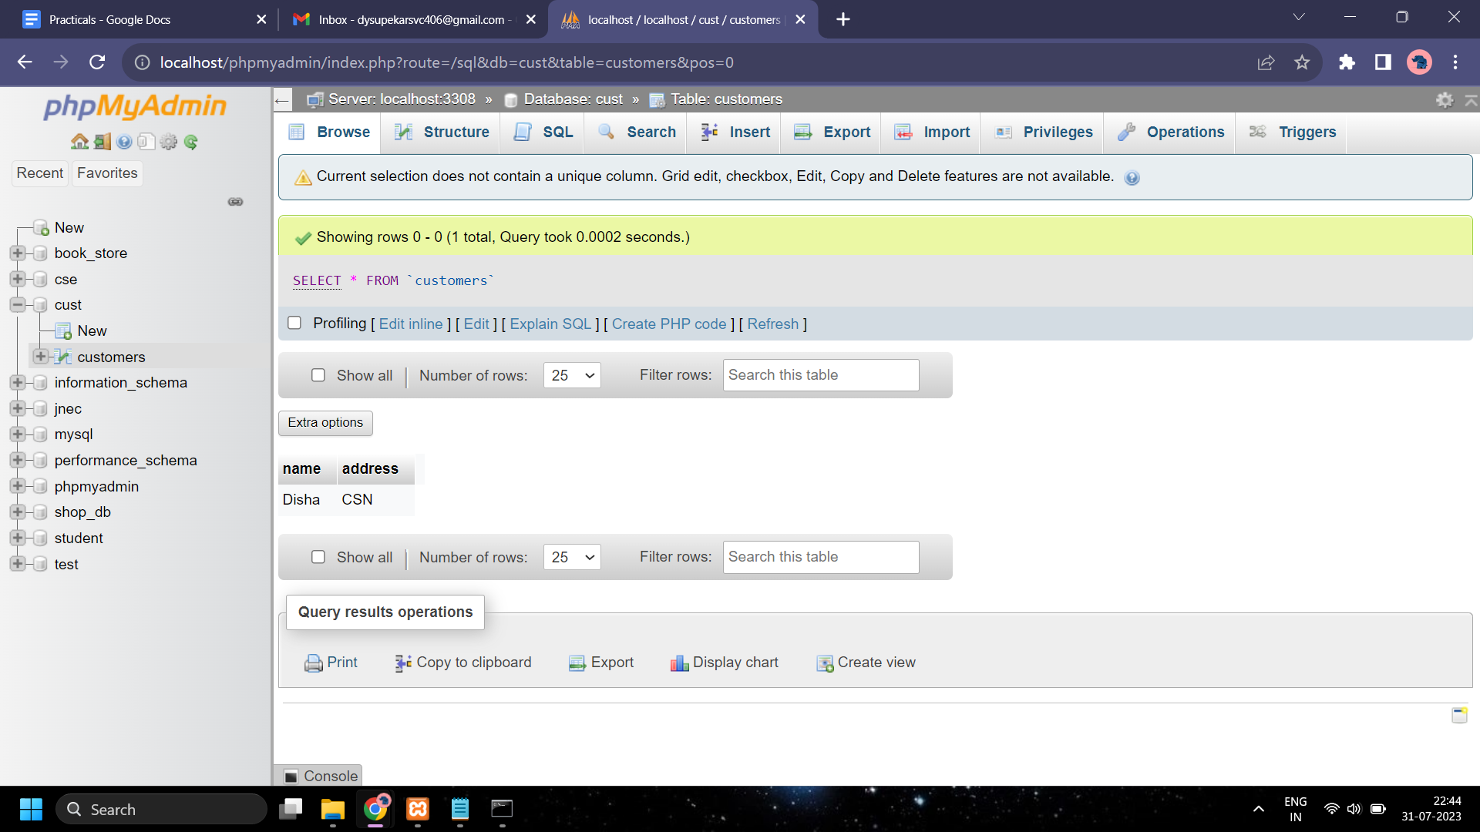

**CODE: (Delete)**

var mysql = require('mysql');

var con = mysql.createConnection({

host: "localhost",

user: "root",

password: "",

port: 3308,

database: "CUST"

});

con.connect(function(err){

if (err) throw err;

console.log("Connected!");

var nameToDelete = "Disha";

var sql = "DELETE FROM customers WHERE name = ?";

con.query(sql, nameToDelete, function(err, result){

if (err) throw err;

console.log("1 record deleted");

});

});

**OUTPUT:**

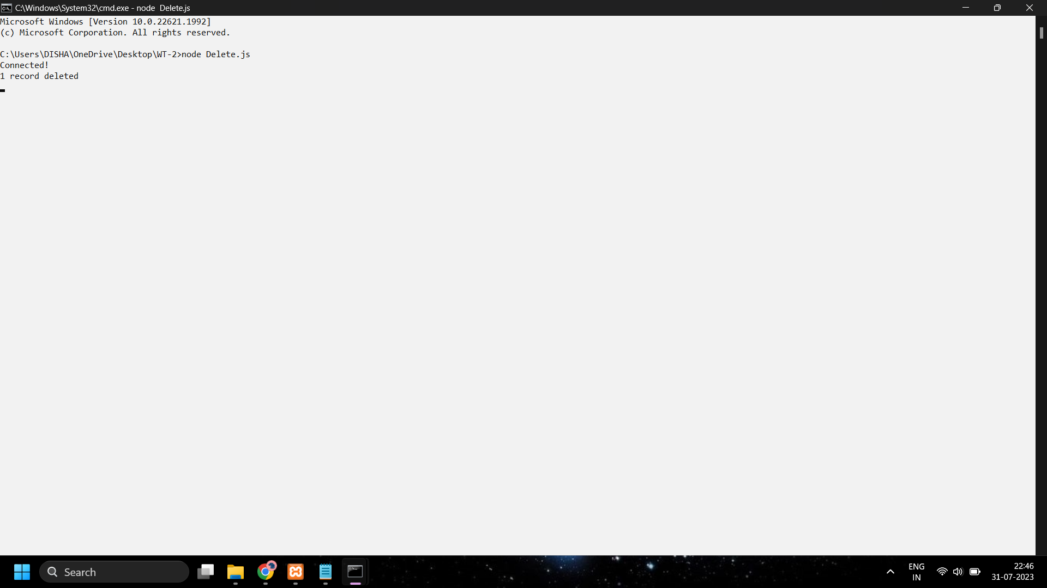

**CODE: (Test.js)**

var http = require('http');

var dt = require('./myfirstmodule');

http.createServer(function (req, res) {

res.writeHead(200, {'Content-Type': 'text/plain'});

res.write("The date and time are currently: " + dt.myDateTime());

res.end('\nHello World\n');

}).listen(1337, "127.0.0.1");

console.log('Server running at<http://127.0.0.1:1337/>');

**CODE: (myfirstmodule.js)**

exports.myDateTime = function () {

return Date();

}

**OUTPUT:**

